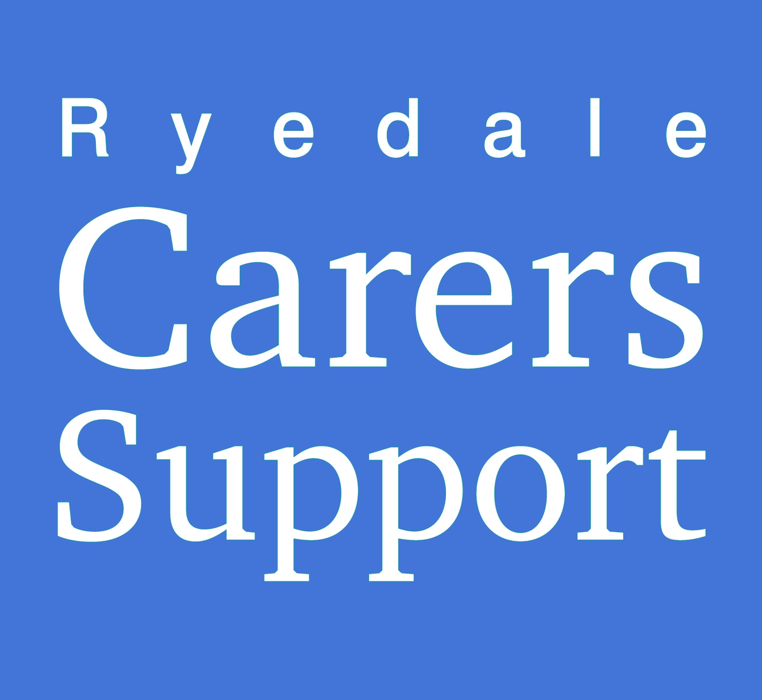
RYEDALE CARERS SUPPORT
Charity Registration No 1175552
The Old School, Tinley Garth
Kirkbymoorside YO62 6AR
Telephone (01751 432288)

MONTHLY RETURN FORM

It is important that Monthly Returns are forwarded, as it enables Ryedale Carers Support to prove that we are meeting our contract with County Council HAS, and thus ensures that our funding and work continues.
Returns need to be received back to us 10 days after being recieved

If you wish to claim for any mileage or travel expenses incurred during your visits, please complete and return the separate claim form.
Please list number of phone calls you have made this month in place of visits.

Name of volunteer……………………………………………………………….

Client  (person you are visiting) | How many visits | Phone calls | Hours spent | Activities attended eg Sing a longs, One stop events etc
1)
2)
3)
4)
Use this space for any comments/messages

If you would prefer to receive your monthly return or expenses for by email, please tick the box and provide a valid email address. Or contact Sam at Ryedalecarers4@gmail.com or call us on 01751 432288

I am happy to receive emails

Email Address __________________________________________________________________

Please return this form in the envelope provided.

